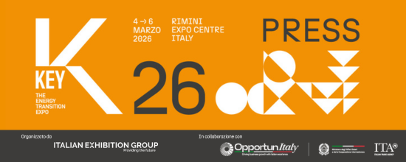

press release

THE KEY 2026 CONFERENCE PROGRAMME
TECHNOLOGIES, STRATEGIES AND VISION FOR THE FUTURE OF ENERGY

- From 4th to 6th March 2026 at Rimini Expo Centre, the IEG (Italian Exhibition Group) event on energy transition and efficiency
- Key topics on the agenda will include finance and innovative tools for controlling energy costs
- Other areas of focus: artificial intelligence, construction supply chain efficiency, energy self-sufficiency in Africa, regulatory scenarios and developments, hydrogen, renewables and the electric transition in mobility.
Rimini, XXX 2025 – The new energy ecosystem will be forged at KEY – The Energy Transition Expo, the leading event organised by IEG (Italian Exhibition Group) in Europe, Africa and the Mediterranean basin, which, from 4th to 6th March 2026, will transform Rimini Expo Centre into an energy transition and efficiency hub where the green and decarbonised future will take shape.

The sector’s global community will be greeted with an international programme of events defined by the event's Technical Scientific Committee, chaired by Professor Gianni Silvestrini and made up of national and international institutions, industrial trade associations, technical-scientific associations, researchers, consortia, agencies and institutes. An abundant programme of insights, brimming with content to keep pace with the most recent regulatory developments, cutting-edge technologies and the latest innovations on the market for rationalising consumption and controlling energy costs.

THE KEY 2026 PROGRAMME: MACRO THEMES AND UNMISSABLE APPOINTMENTS
Finance to support the energy transition: Finance is playing an increasingly strategic role in the energy transition. Solutions such as PPAs, dedicated funds and innovative financing models, enable companies to mitigate energy cost volatility. That is why finance in support of green transformation will be a focal point in the KEY 2026 programme with conferences on new tools to support investment in renewables and energy efficiency. Discussions will focus on new forms of financing, green bonds and bonds for sustainable projects, as well as participatory models involving citizens, businesses and communities. Ample space will be given to development opportunities linked to funds and incentives to accelerate decarbonisation, cost-benefit analyses, and risk financing.

ForumTech: KEY 2026 will feature the return of ITALIA SOLARE's ForumTech with a new edition that will focus even more closely on technological and regulatory developments in the photovoltaic sector. Together with experts, businesses and institutions, an entire day will be dedicated to exploring the most advanced solutions for digitalisation, monitoring, smart energy management, and integration with storage systems.

The construction supply chain: For the first time this year, KEY will present the Report on the state of energy sustainability in the construction supply chain, drafted in collaboration with FEDERCOSTRUZIONI.

New technologies for the energy of the future: Innovation will be at the heart of the next edition of KEY with a focus on data centres, AI and IoT systems applied to the energy sector for the predictive maintenance and management of renewable energy plants, decarbonisation of the built environment and energy management.

Renewables and storage for tomorrow's energy system: Photovoltaics, storage and wind power will play a predominant role in KEY's programme. The current situation regarding agrivoltaics in the national, European and international landscape will be discussed, as well as offshore wind power, from innovative materials to the first projects authorised in Italy, and storage systems for the national electricity grid’s flexibility and stability, including the industrial sector. Particular attention will be paid to the issue of territorial acceptability, reflecting on challenges, opportunities and strategies for combining the development and construction of large renewable energy plants with the consent and participation of local communities. Hydroelectric power and the release of investments to enable its potential will also be on the agenda.

Hub ports for the green transition: KEY will confirm the centrality of ports in the future of energy due to their key role in the development of the offshore industrial supply chain. The events scheduled will analyse the infrastructure requirements, adaptation strategies and public-private partnerships needed to ensure efficiency and competitiveness, bringing together institutions, port operators, companies and the world of research.

Energy efficiency and sustainable cities: Comprehensive energy efficiency will play a key role in accelerating decarbonisation. KEY will discuss the efficiency of public housing in light of the NRRP (National Recovery and Resilience Plan), finance, solutions for small and medium-sized enterprises, ESCOs (Energy Service Companies), white certificates, measurement and verification (M&V) and energy accounting, without forgetting efficient and intelligent public lighting and the new prospects offered by second-generation meters.

Hydrogen for the transition of hard-to-abate sectors and transport: The KEY 2026 conference programme will also include hydrogen with events dedicated to the role of this vector in the decarbonisation of hard-to-abate industrial sectors: Italian regional Hydrogen Valleys; the manufacture of clean technologies in Italy and Europe in light of the Net Zero Industry Act; and e-fuels, strategic for the decarbonisation of heavy transport. Collaboration with Hannover Fairs International GmbH (HFI), the Italian subsidiary of Deutsche Messe AG, which jointly organises the HYPE - Hydrogen Power Expo area with IEG, will also provide an opportunity for international dialogue with the presentation of authentic business cases.

New mobility and the sector's transition to electric power: KEY 2026 will also discuss the latest regulatory updates in the electric vehicle charging sector with a particular focus on AFIR regulations and infrastructure along road and motorway networks, especially for heavy goods vehicles. The challenges and opportunities of developing an efficient and widespread network in Italy and Europe will be analysed, as well as the steps necessary to successfully launch the electrification of company fleets. The focus will be on synergies between vehicles and the electricity grid, batteries and storage systems, and new skills, professions and training courses to address this major transformation in the automotive industry.

Spotlight on Africa's energy self-sufficiency: Two events organised by Res4Africa will focus on Africa's economic and sustainable growth, highlighting the potential of photovoltaics and storage systems for the continent's energy transition and the need to strengthen financing tools to improve access to reliable and sustainable electricity.

Renewable Energy Communities are the key to a fair transition: There will be plenty of opportunities to take stock of Italy’s Renewable Energy Community numbers with the presentation of best practices from Legambiente and Kyoto Club’s BeComE project with AzzeroCO2, the presentation of the ENEA Observatory and the development of this model in schools, organized by RSE.

Regulations and future scenarios: New regulations and tools to support the development of renewables, fake news and false myths, investments, new scenarios and recent major global challenges will be among the main topics at KEY 2026. The first edition of the Green Paper on Energy Transition, produced with the contribution of the majority of Italian associations in the energy efficiency sector, will be presented.

The KEY 2026 conference schedule is constantly being updated and can be viewed on the event website at the following link: www.key-expo.com/eventi

KEY CHOICE – Unlock the future of PPAs
Just prior to KEY, on Tuesday 3rd March 2026 at Rimini’s Palacongressi Conference Centre, the third edition of KEY CHOICE – Unlock the future of PPAs, KEY – The Energy Transition Expo’s B2B event specifically for Power Purchase Agreements, organized by IEG (Italian Exhibition Group) in collaboration with Elemens.

ABOUT KEY 2026
Event: International trade show; Organization: Italian Exhibition Group S.p.A.; Frequency: annual; Edition: 4th; Dates: 4-6 March 2026; mail keyenergy@iegexpo.it; Website: http://www.key-expo.com; Facebook: https://www.facebook.com/keyexpo/; Instagram: https://www.instagram.com/key_expo/; LinkedIn: https://www.linkedin.com/company/keyenergy/

PRESS CONTACT KEY - ITALIAN EXHIBITION GROUP
head of media & corporate communication: Elisabetta Vitali; press office manager: Marco Forcellini, Pier Francesco Bellini; international press office coordinator: Silvia Giorgi; press office coordinator: Luca Paganin; press office specialists: Nicoletta Evangelisti, Mirko Malgieri; media@iegexpo.it

MEDIA AGENCY: Smartitaly Communications
Sara Scatena, s.scatena@smartitaly.it, mob. +39 338 7836985; Francesca Pericolo, f.pericolo@smartitaly.it, mob. +39 327 986 1860

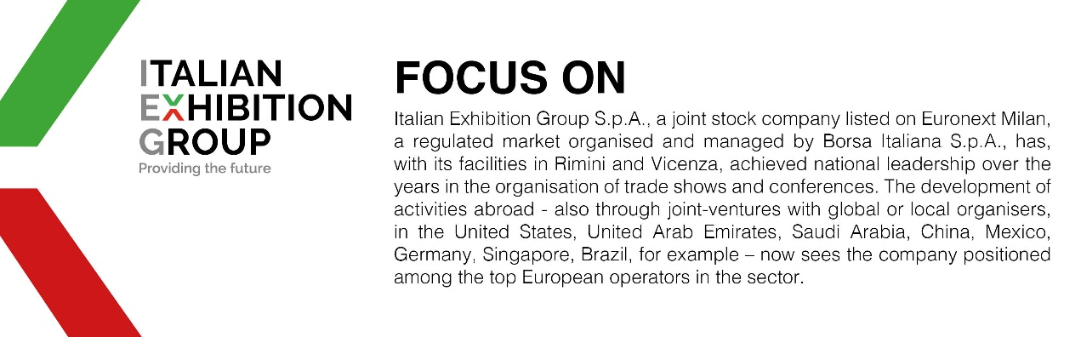

This press release contains forecast elements and estimates that reflect the management’s current opinions (“forward-looking statements”), particularly regarding future management performance, realization of investments, cash flow trends and the evolution of the financial structure. For their very nature, forward-looking statements have a component of risk and uncertainty, as they depend on the occurrence of future events. The effective results may differ (even significantly) from those announced, due to numerous factors, including, only by way of example: food service market and tourist flow trends in Italy, gold and jewellery market trends, green economy market trends; the evolution of raw material prices; general macroeconomic conditions; geopolitical factors and evolutions in the legislative framework. Moreover, the information contained in this release does not claim to be complete, and has not been verified by independent third parties. Forecasts, estimates and objectives contained herein are based on the information available to the Company as at the date of this release.

